

…a season to dream, explore and recommit to faith in action!



Sunday March 8, 2026 – 10:30 AM
Third Sunday of Lent – Morning Prayer

PRELUDE “A Quiet Prayer” Richard Blake

SILENT PROCESSION
GREETING
Blessed be God who loves us in our limitations and fosters our loving all whom we meet.
Blessed be the ones who welcome the Christ in us all.

CONFESSION

During the season of Lent we take inventory of our lives, as we confess our separation from God, our neighbors, and ourselves. A period of silence for personal prayer and reflection will be observed.

Let us pray together;
Most merciful God, we confess before you and one another that we have fallen short of the wholeness you desire for us. We have betrayed your trust. We have been less than you created us to be. We have failed to speak out against that which is evil. We have cooperated with systems of injustice. We have built our prosperity upon the lives of others who suffer. We know that you accept and forgive us. We know that you are always ready to heal us of our ignorance and lack of concern for others. Help us to open our hearts to your love, that in so doing we may love ourselves along with our neighbor, strive for justice for all people, and hold forth the vision of what is possible. This we pray as Jesus, our great teacher modeled and who chose life in choosing death. AMEN.
ABSOLUTION
The Officiant says to the People:
God freely offers forgiveness and calls us to turn and live in the joy of God’s love. God has given power to all people to forgive one another and themselves. Therefore, know that God forgives us. Therefore let us forgive ourselves and accept others forgiven and be free.

COLLECT OF THE DAY
God is with you.
And also with you.
Let us pray.

Lord of the wellspring, source of life and truth: Jesus asked for water from the hands of a woman in the land of the stranger; may he teach us to name our need, to love our neighbor and to worship you in spirit and truth, through Jesus Christ, who shows us who we are. AMEN.
“O God, we hear and hear, and do not understand. We see and see, but do not perceive. Sharpen our memory, unlock our grief, teach us to name what is evil and refuse it: even when it seems normal even when it seems necessary even when it is commanded by religion; then, now, always.” AMEN.

SCRIPTURE APPOINTED for the DAY

A reading from the Book of Exodus 17:1-7

The Israelites left the desert of Syn to travel by stages, as YHWH had directed them. They camped at Rephidim, but found no drinking water.
Again they turned on Moses, saying, “Give us drinking water.”
Moses replied, “Why do you quarrel with me? Why do you test YHWH?”
But the people were thirsty, and complained even more to Moses. “Why did you bring us out of Egypt only to make us and our children and our livestock die of thirst?”
Moses appealed to YHWH. “What am I to do with these people? They are ready to stone me!” YHWH answered Moses, “Take some of the elders and move to the front of the people. Take with you the staff with which you struck the Nile. Go! 6 I will wait for you there by the rock of Horeb.† Strike the rock, and water will come out of it for the people to drink.”
And Moses did so, in the sight the elders.
Moses named the place Massah, “Testing,” and Meribah, “Quarreling,” for the Israelites tested YHWH when they said, “Is YHWH with us or not?”
Hear what the Spirit is saying to the Church. Thanks be to God

Psalm 95 (NCH 683) Krista will chant the verses, the congregation sings the response
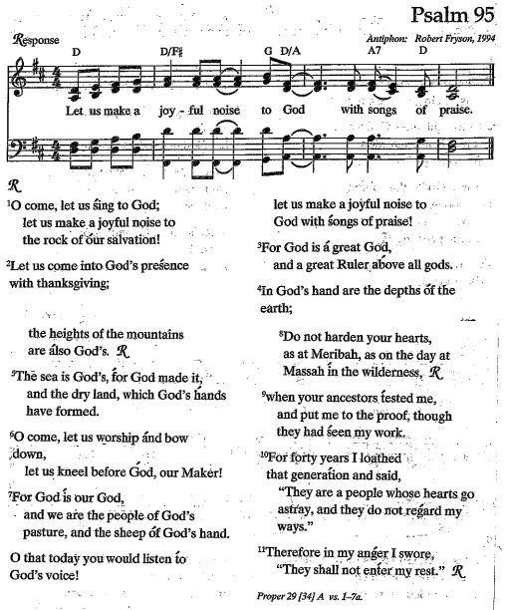

A Contemporary reading is Prisoner of the Sand"

In 1935, the pilot and writer Antoine Saint Exupéry and his mechanic-navigator crash landed in the Sahara Desert without provisions. Impossibly, they survived the next days with no more than a few ounces of water. After being rescued by a passing Bedouin, Saint Exupéry wrote an account of this adventure in his 1939 Wind, Sand, and Stars. As we an imagine water began to assume a larger part of his awareness:

Water, thou has no taste, no color, no odor; canst not be defined, art relished while ever mysterious. Not necessary to life, but rather life itself, thou fillest us with a gratification that exceeds the delight of the senses. By thy might, there return into us treasurers that we had abandoned. By thy grace, there are released in us all the dried-up runnels of our heart. Of the riches that exist in the world, thou art the rarest and also the most delicate--thou so pure within the bowels of the earth! A man may die of thirst lying beside a magnesian spring. He may die within reach of a salt lake. He may die though he hold in his hand a jug of dew, if it be inhabited by evil salts. For thou, water, art a proud divinity, allowing no alteration, no foreignness in thy being. And the joy that thou spreadest is an infinitely simple joy.

Hear what the Spirit is saying to the church
Thanks be to God

A Reading from the Gospel of John 4:5-42

[Jesus] stopped at Sychar, a town in Samaria, near the tract of land Jacob had given to his son Joseph, and Jacob’s Well was there. Jesus, weary from the journey, came and sat by the well. It was around noon.
When a Samaritan woman came to draw water, Jesus said to her, “Give me a drink.” The disciples had gone off to the town to buy provisions.
The Samaritan woman replied, “You’re a Jew. How can you ask me, a Samaritan, for a drink?”—since Jews had nothing to do with Samaritans.
Jesus answered, “If only you recognized God’s gift, and who it is that is asking you for a drink, you would have asked him for a drink instead, and he would have given you living water.”
“If you please,” she challenged Jesus, “you don’t have a bucket and this well is deep. Where do you expect to get this ‘living water’? Surely you don’t pretend to be greater than our ancestors Leah and Rachel and Jacob, who gave us this well and drank from it with their descendants and flocks?”
Jesus replied, “Everyone who drinks this water will be thirsty again. But those who drink the water I give them will never be thirsty; no, the water I give will become fountains within them, springing up to provide eternal life.”
The woman said to Jesus, “Give me this water, so that I won’t grow thirsty and have to keep coming all the way here to draw water.”
Jesus said to her, “Go, call your husband and then come back here.”
“I don’t have a husband,” replied the woman.
“You’re right—you don’t have a husband!” Jesus exclaimed. “The fact is, you’ve had five, and the man you’re living with now is not your husband. So what you’ve said is quite true.”
“I can see you’re a prophet,” answered the woman. “Our ancestors worshiped on this mountain, but you people claim that Jerusalem is the place where God ought to be worshiped.”
Jesus told her, “Believe me, the hour is coming when you’ll worship Abba God neither on this mountain nor in Jerusalem. You people worship what you don’t understand; we worship what we do understand—after all, salvation is from the Jewish people. Yet the hour is coming—and is already here—when real worshipers will worship Abba God in Spirit and truth. Indeed, it is just such worshipers whom Abba God seeks. God is Spirit, and those who worship God must worship in spirit and truth.”
The woman said to Jesus, “I know that the Messiah—the Anointed One—is coming and will tell us everything.”
Jesus replied, “I who speak to you am the Messiah.”
The disciples, returning at this point, were shocked to find Jesus having a private conversation with a woman. But no one dared to ask, “What do you want of him?” or “Why are you talking with her?”
The woman then left her water jar and went off into the town. She said to the people, “Come and see someone who told me everything I have ever done! Could this be the Messiah?” At that, everyone set out from town to meet Jesus.
Meanwhile, the disciples were urging Jesus, “Rabbi, eat something.”
But Jesus told them, “I have food to eat that you know nothing about.”
At this, the disciples said to one another, “Do you think someone has brought him something to eat?”

Jesus explained to them, “Doing the will of the One who sent me and bringing this work to completion is my food.
Don’t you have a saying, ‘Four months more and it will be harvest time’? I tell you, open your eyes and look at the fields—they’re ripe and ready for harvest! Reapers are already collecting their wages; they’re gathering fruit for eternal life, and sower and reaper will rejoice together.
So the saying is true:
‘One person sows; another reaps.’
I have sent you to reap
what you haven’t worked for.
Others have done the work,
and you’ve come upon the fruits of their labor.”

Many Samaritans from that town believed in Jesus on the strength of the woman’s testimony—that “he told me everything I ever did.” The result was that, when these Samaritans came to Jesus, they begged him to stay with them awhile. So Jesus stayed there two days, and through his own spoken word many more came to faith. They told the woman, “No longer does our faith depend on your story. We’ve heard for ourselves, and we know that this really is the savior of the world.”

The Gospel of the Savior.
Praise to you, O Christ

HOMILY

Profession of Faith

We believe in God, who creates all things, who embraces all things, who celebrates all things, who is present in every part of the fabric of creation.
We believe in God as the source of all life, who baptizes this planet with living water.
We believe in Jesus Christ, the suffering one, the poor one, the malnourished one, the climate refugee, who loves and cares for this world and who suffers with it.
And we believe in Jesus Christ, the seed of life, who came to reconcile and renew this world and everything in it.
We believe in the Holy Spirit, the breath of God, who moves with God and who moves among and with us today. And we believe in the hope that one day God will put an end to death and all destructive forces.

PRAYERS and PETITIONS of the PEOPLE
O God of our hearts, God of love, you are with us in every transition and change.
We recall your deep compassion, presence and abounding love.
We thank you for the gifts, talents and skills with which you have blessed us.
We thank you for the experiences that have brought us to this moment.
We thank you for the work of others that gives breadth and depth to our own work.
Be with us as we move forward, rejoicing with you and supporting one another.
God of mercy, God of peace, hear our prayer.

During this season of Lent, let us hold close to our hearts all those in need, those who
suffer, and those who mourn. In the prayers that follow, you are invited to respond
with your own concerns and thanksgivings related to the particular focus of each
petition

For those who are experiencing homelessness, unemployment, underemployment or
loneliness, that we may lift each other’s’ burdens.
(You are invited to add your specific concerns and thanksgivings in this area.)
O God of mercy,
Receive our prayer.
For the health and regeneration of our living planet Earth, that we may accept our
responsibility for its care and future.
(You are invited to add your specific concerns and thanksgivings in this area.)
O God of creation,
Receive our prayer.

For all who govern within our towns, states and nations, that they will hear and heed
the cry of all in need, and awaken to the call for peace.
(You are invited to add your specific concerns and thanksgivings in this area.)
O God of reconciliation,
Receive our prayer

For those who struggle to see you in their lives and relationships, that we may reflect
your Divine love to them.
(You are invited to add your specific concerns and thanksgivings in this area.)
O God of tenderness,
Receive our prayer.

For those for whom the Immigration Customs Enforcement Agency has caused pain, suffering, and hardship, that those around them will respond tenderly.
(You are invited to add your specific concerns and thanksgivings in this area.)
O God of compassion,
God of peace, receive our prayer.

For all who are harmed because of their race or ethnicity, that we may work to
dismantle systems of oppression.
(You are invited to add your specific concerns and thanksgivings in this area.)
O God of love,
Receive our prayer.

We now pray the concerns and thanksgivings of this parish family.
(You are invited to add additional concerns and thanksgivings.)
We know that you hear our prayers, O God. During this season of Lent, help us to
open ourselves to the needs of those around us, that by so doing, we may reveal the
beauty of your beloved community. Amen.

THE PEACE
The Savior will not command legions of angels nor ride the machine of holy war; the Redeemer will become a slave, take our hate into their heart and win us with forgiveness, for the Savior is God’s unexpected peace.

ANNOUNCEMENTS

OFFERTORY – “Give Me Jesus” - Mark Hayes
Krista Donough – Soprano, Chris Henke - Piano

GATHERING at the TABLE

God be with you!
And also with you.
Lift up your hearts.
We lift them to God.
Let us give thanks to the Creator.
It is right to give God thanks and praise.

We thank you, desert Mother, for in the valley of dry bones you create hearts of flesh quickened by the Spirit's breath. We thank you, wise Sister that you walk in cloud and fire with your lost and faithless people.
We thank you, Son of heaven, that you empty yourself of might and glory and set your face toward the fickle crowd, the cruel empire, and the faithful despisers.
We welcome you as God's own son whose cross brings to nothing the violence of the world and reveals another wisdom outside the city walls.
Therefore, with all who follow your way with the traders and tax collectors, the soldiers and prostitutes, and all who caught a glimpse of glory in the humanity you shared, we worship God's own holiness revealed in sweat and tears, as we sing:

Holy, Holy, Holy, my heart, my heart adores you.
My heart is glad to say the words, you are the holy one!

Holy and gracious Creator: In your infinite love you made us for yourself, and, when we had fallen astray and became vulnerable to evil you, in your mercy, sent Jesus Christ, your only and eternal Son, to share our human nature, to live and die as one of us, to reconcile us to you, the God and Creator of all.
Before Jesus’s mortal death, he taught us and we are bold to pray in whatever language or form that brings us closer to God,

Our Mother, our Father in heaven, hallowed be your Name,
your kingdom come, your will be done, on earth as in heaven.
Give us today our daily bread.
Forgive us our sins as we forgive those who sin against us.
Save us from the time of trial, and deliver us from evil.
For the kingdom, the power, and the glory are yours, now and forever. AMEN.

As we gather here today, we are sanctified by Jesus’s love and the gift of the Holy Spirit which sustains us this day and always. All this we offer in the unity, constancy and peace; at the last day let us join with all our ancestors and forbearers into the joy of everlasting life.

Prayer of Thanksgiving

Let us pray together
Creator of this gathering beyond measure and price; we thank you for meeting us in our brokenness so that none might be lost: liberate us now to share our bread with neighbors and strangers, each receiving from the other what we need to be ourselves. AMEN.

BENEDICTION

Closing Hymn God Jesus, Who Throughout Forty Days (NCH 211)
1 Lord Jesus, who through forty days
for us did fast and pray,
Teach us with you to mourn our sins,
and close by you to stay.

2 As you with Satan did contend,
and did the victory win,
O give us strength to persevere,
in you to conquer sin.

3 And through these days of penitence,
and through this Passion-tide,
Yes, evermore, in life and death,
O Christ, with us abide.
4 Abide with us, till when this life
of suffering shall be past,
An Easter of unending joy
we may attain at last

Postlude “What Wondrous Love” - Sarah Douglas

ANNOUNCEMENTS - Mark Your Calendar!

Palm Sunday and Holy Week: Palm Sunday, March 29th: Service at 10:30 a.m. Maundy Thursday, April 2nd: Service at 6:30 p.m. Good Friday, April 3rd, at 6:30 p.m.
Easter Sunday, April 5th: Service at 10:30 a.m.

The Serendipity Stitchers welcome you. Tuesdays at 1:30 p.m. 3/3 and 3/17. ﻿Our gatherings are always full of laughter, delicious treats, and plenty of good company. No experience necessary.
Please get in touch with Veronica for more information.
Annual Meeting: March 22, following the 10:30 service.
The Whippany River Clean-up Saturday, 3/21/2026: The Whippany River Clean-up! 8:30 am-12 noon. 59 Spring Street, Morristown. See the Peg after the service, of fill out the signup sheet near the MLK portrait.
Easter Flowers and Music dedication: A beautiful tradition at Redeemer is the Easter display on all of the altars and the lovely music that fills our Church through Easter. Any contribution is appreciated. Place the completed form or envelope in the offering plate or bring it to the church office before

Palm Sunday, March 29th. Please print clearly on the form. Any questions, contact Sandra at office@redeemermorristown.org
The Book Group meets online at 7pm: 3/30/26 THE HORSEWOMAN by James Patterson and Mike Lupica. Please contact Veronica for the link. Please support your local bookshop and Redeemer by ordering from our online Bookshop by going here. https://bookshop.org/shop/Redeemer

Keep updated with all that is going on at Redeemer
Visit our website: https://redeemermorristown.org/ for further information and to sign up for our newsletter.

Please "like" and check out our Facebook page at http://bit.ly/FBchurch or follow us on Instagram - @RedeemerMorristown - http://bit.ly/Instachurch.
We are now on BlueSky -@redeemermorristown.bsky.social , https://bit.ly/RedeemerBSKY

Donate easily, by credit card, or directly from your bank account. Scan this QR code image with a smartphone's QR decoder, instantly connecting you to the mobile version of our web page. Try it!

Visit our website- www.redeemermorristown.org and click on “Donate” in the upper right-hand corner.
Or (can you tell we want to make it easy for you?!), go to: http://tinyurl.com/RedeemerDonateNow

From Rev. Willie J. Smith

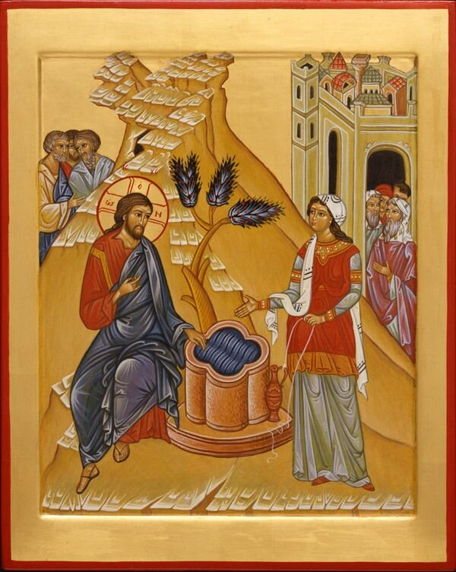
As we continue through our journey during Lent ask yourself, “are you being turned inside out?” This is time to look inside ourselves to develop an understanding of how we see God and how God sees us , individually and collectively. These next three Sunday the Gospel has invites us to look at individuals who model for us transformation.
This Sunday it is the Gospel Story of the Samaritan Woman at the Well. John 4:5-42 This is the first of three long Gospels that we will hear in the coming weeks. A woman, non-Jew and outcast. Read the story of what the Spirit is saying to you.

The First Evangelist, Equal to the Apostles
The Eastern Church never abandons the Samaritan woman to obscurity in her city. She did not bring one or two disciples to Jesus like Andrew and Philip, but she brought a whole city. And not through empty superlatives but with the cleverness and conviction of her personal narrative.
The Orthodox give her a name, Photini (“the enlightened one”), a feast day (February 26), a title (Evangelist and Apostle), and a story.
Photini was present at the very origin of the church when the Holy Spirit empowered the company of believers at Pentecost. She brought along her family of five sisters, Anatole, Photo, Photis, Paraskeve, Kyriake, and her two sons, Photeinos and Joseph. Like the apostles, she traveled, proclaiming the Good News “to the ends of the earth.” While she was on a preaching mission in Carthage, Jesus came to her in a dream and at his urging she left for Rome to preach where Christian persecution was most severe. About to be arrested herself, she anticipates the soldiers and approaches Nero's palace on her own.
Nero tortures Photini, her sisters, her youngest son and the other North Africans who accompanied her. When that failed, Nero placed the women in a room full of gold, thinking the temptation of riches would drive away their love for Jesus. Nero brought his daughter Domnina to persuade them, but instead, Photini and Domnina admired one another and became friends. Domnina was baptized and then distributed the room full of gold to the poor.
Furious, Nero ordered prison and further torture for Photini and her company. During the next three years the prison-house became a “house of God” drawing many Romans to worship, to conversion, and baptism. Her son, her sisters, and the rest of Photini's friends were beheaded. She also longed for the crown of martyrdom, and she finally died of the results of torture and released her soul to God.

Proclamation

This is how God acts-like the man searching for his lost sheep, like the woman tirelessly sweeping for her lost coin. Jesus thus images of God as a woman searching for one of her ten coins, looking for money that is terribly important to her. In telling the parable of the woman desperately searching for her money, Jesus articulates God’s own concern, a concern that determines Jesus’ own practice for table community with sinners and outcasts. The parable then challenges the hearer: Do you agree with attitude of God expressed in the woman’s search for her lost “capital”? –
In Memory of Her by Elisabeth Schussler Fiorenza



From Deacon Erik

I encourage each of you, in this season of Lent, to dream and imagine the Church of Redeemer in the 21st Century. I continue to challenge you to look at who you are as a leader in the Episcopal church, offering not just inclusive language but a congregation that acts on their faith.

Taking this time to dream and explore encourages breaking out of stagnant routines and imagining a better & brighter future. The church of the Redeemer is filled with people who believe in faith inspired by the hope that life is eternal, supported by the sustaining promise of God’s unquestionable love.

Complacency leads to defeat and exclusion. This is not what I have been told is the spirit of the Church of the Redeemer. Actively exploring new initiatives and ministries is the gift of our imaginations. Now more than ever, it is time for us to dream.

I challenged you all in Advent to do some cleaning and clearing of spaces. The specific space was and is the church undercroft, which is cluttered and presents neglect. I have been told there are treasures in this space, and it is time to rescue these treasures. The opportunity to name and identify these artifacts of Redeemer’s history will unearth many of the seeds of your dreams for the Church of the Redeemer.

These are gifts that require moving from dreams to planning and action that will chart the course of faith in action, our ministry in 2026, and thereafter. Let us welcome Eastertide with the joy of resurrection.

In last week’s Gospel, we learned that Jesus was talking with Elijah and Moses as witnessed by Peter, James, and John. We also learned that Peter wanted to preserve this with individual huts for Jesus and the two prophets. Instead, God exclaimed this is my son whom I am pleased, listen to him. In the moment of this dramatic transfiguration, belief is realized.




