As we continue through our journey during Lent ask yourself, “are you being turned inside out?” This is time to look inside ourselves to develop an understanding of how we see God and how God sees us , individually and collectively. These next three Sunday the Gospel has invites us to look at individuals who model for us transformation.
This Sunday it is the Gospel Story of the Samaritan Woman at the Well. John 4:5-42 This is the first of three long Gospels that we will hear in the coming weeks. A woman, non-Jew and outcast. Read the story of what the Spirit is saying to you.

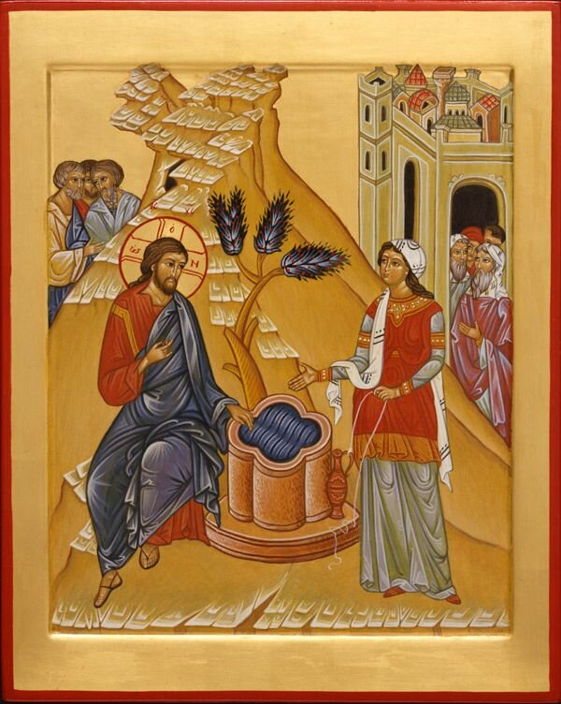

The First Evangelist, Equal to the Apostles
The Eastern Church never abandons the Samaritan woman to obscurity in her city. She did not bring one or two disciples to Jesus like Andrew and Philip, but she brought a whole city. And not through empty superlatives but with the cleverness and conviction of her personal narrative.
The Orthodox give her a name, Photini (“the enlightened one”), a feast day (February 26), a title (Evangelist and Apostle), and a story.
Photini was present at the very origin of the church when the Holy Spirit empowered the company of believers at Pentecost. She brought along her family of five sisters, Anatole, Photo, Photis, Paraskeve, Kyriake, and her two sons, Photeinos and Joseph. Like the apostles, she traveled, proclaiming the Good News “to the ends of the earth.” While she was on a preaching mission in Carthage, Jesus came to her in a dream and at his urging she left for Rome to preach where Christian persecution was most severe. About to be arrested herself, she anticipates the soldiers and approaches Nero's palace on her own.
Nero tortures Photini, her sisters, her youngest son and the other North Africans who accompanied her. When that failed, Nero placed the women in a room full of gold, thinking the temptation of riches would drive away their love for Jesus. Nero brought his daughter Domnina to persuade them, but instead, Photini and Domnina admired one another and became friends. Domnina was baptized and then distributed the room full of gold to the poor.
Furious, Nero ordered prison and further torture for Photini and her company. During the next three years the prison-house became a “house of God” drawing many Romans to worship, to conversion, and baptism. Her son, her sisters, and the rest of Photini's friends were beheaded. She also longed for the crown of martyrdom, and she finally died of the results of torture and released her soul to God.

Proclamation
This is how God acts-like the man searching for his lost sheep, like the woman tirelessly sweeping for her lost coin. Jesus thus images of God as a woman searching for one of her ten coins, looking for money that is terribly important to her. In telling the parable of the woman desperately searching for her money, Jesus articulates God’s own concern, a concern that determines Jesus’ own practice for table community with sinners and outcasts. The parable then challenges the hearer: Do you agree with attitude of God expressed in the woman’s search for her lost “capital”? – In Memory of Her by Elisabeth Schussler Fiorenza

